**EXP 26:CREATE A SQL STORAGE SERVICE AND PERFORM A BASIC QUERY USINGANY PUBLIC CLOUD SERVICE PROVIDER (AZURE/GCP/AWS) TO DEMONSTRATE DATABASE AS A SERVICE (DAAS)**

**AIM:** CREATE A SQL STORAGE SERVICE AND PERFORM A BASIC QUERY USINGANY PUBLIC CLOUD SERVICE PROVIDER (AZURE/GCP/AWS) TO DEMONSTRATE DATABASE AS A SERVICE (DAAS)

**PROCEDURE:**

**Step 1: Log in to Azure Portal**

1. Open https://portal.azure.com
2. Sign in using your **Azure student or free account**.

**Step 2: Create a Resource Group**

1. Search for **“Resource Groups”** in the search bar.
2. Click **Create** → enter details:
   * **Resource Group Name:** SQLGroup
   * **Region:** Choose nearest region (e.g., East US, Central India).
3. Click **Review + Create** → **Create**.

**Step 3: Create an Azure SQL Database**

1. In the search bar, type **“SQL Database”** → Click **Create**.
2. Fill details:
   * **Subscription:** Azure for Students / Free
   * **Resource Group:** SQLGroup
   * **Database Name:** StudentDB
3. Under **Server**, click **Create New Server**:
   * **Server Name:** student-sqlserver
   * **Server Admin Login:** adminuser
   * **Password:** (enter a secure password)
   * **Location:** Same as resource group
4. Click **Next → Networking**, then allow public access.
5. Click **Review + Create** → **Create**.

**Step 4: Configure Firewall Rules**

1. After deployment, open your SQL database → Click **Set Server Firewall**.
2. Click **Add Client IP** to allow your computer to access the database.
3. Click **Save**.

**Step 5: Query the Database (Using Query Editor)**

1. In the SQL database page, click **Query Editor (Preview)**.
2. Login with the admin username and password.

**Step 6: Verify and Save Results**

* Verify that the table and records are successfully created.
* Take a screenshot of:
  + Database creation summary
  + Query Editor results

**Step 7: Stop/Remove Resources**

* After completion, delete the **Resource Group** to avoid charges:
  + Go to **Resource Groups → SQLGroup → Delete Resource Group.**

**OUTPUT:**

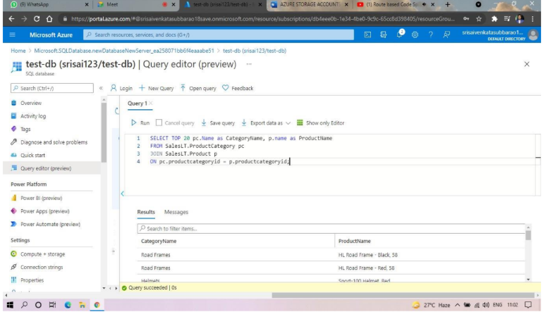

**RESULT:**

A SQL storage service was successfully created on Microsoft Azure, and basic SQL queries were executed using the Query Editor to demonstrate **Database as a Service (DBaaS)** functionality.